Name of the Programme : B.E. Computer Engineering
Course Code : CMP-211
Title of the Course : Software Engineering and Project Management Lab
Number of Credits : 1
AY : 2025-2026

Content
List of Experiments Do the following 10 experiments/ exercises for a mini project.
Sr .No | Name of Experiment | Pg No.
 | Development of problem statement. | 3-4
 | Identification & justification of process model for software development. | 5-6
 | Preparation of software requirement specification (SRS) document. | 7-9
 | Study and development of design documentation. | 10-11
 | Validation of design documentation.
 | Implementation of project and Integration of modules.
 | Development of testing strategies and test cases for the project.
 | Conduction of unit tests for various modules of project and documentation.
 | Conduction of various tests (including integration test) for project and documentation.
 | Preparation of Final Project Report and user Manuel.

Tools Used for Process Model
The following tools are used to study, represent, and implement the selected software process model:
- Microsoft Word / Google Docs
Used for documenting the process model, justification, and phase-wise activities.
- Microsoft PowerPoint
Used to visually represent the process model and its phases.
- Draw.io / Lucidchart
Used for drawing software process model diagrams (Waterfall / Agile / Spiral).
- UML Modeling Tools (StarUML / Visual Paradigm)
Used to create design-related diagrams that align with the selected process model.
- Project Planning Tools (Trello / MS Project – optional)
Used to plan tasks according to different phases of the process model.
- Integrated Development Environment (IDE)
Used during implementation phase as defined by the process model
(e.g., VS Code, Eclipse, PyCharm).

Easy & Common Mini Project Topics
- Online Student Feedback Management System
- Library Management System
- Student Result Management System
- Online Attendance Management System
- College Event Management System
- Online Quiz System
- Hostel Management System
- Online Complaint Management System
- Employee Leave Management System
- Online Voting System (Basic)

🔹 Database-Oriented Topics
- Hospital Management System
- Pharmacy Management System
- Inventory Management System
- Book Store Management System
- Customer Relationship Management (CRM) System

Experiment 1: Development of Problem Statement
Aim:
To define a clear problem statement for the proposed mini project.
Description:
The problem statement explains the existing system, its drawbacks, and the need for a new software solution.
Outcome:
A well-defined problem statement with objectives and scope.

Sample Problem Statement Document
Project Title:
Online Student Feedback Management System

1. Introduction
In educational institutions, student feedback plays a vital role in improving teaching quality and overall academic performance. Traditionally, feedback is collected manually using paper forms, which is time-consuming and inefficient.

2. Existing System
The current feedback system is mostly manual. Students fill feedback forms on paper, which are later collected and analyzed by staff members. This process involves a lot of paperwork and human effort.

3. Limitations of Existing System
- Time-consuming feedback collection
- Chances of data loss or damage
- Manual calculation errors
- Lack of confidentiality
- Difficult to generate reports

4. Proposed System
The proposed Online Student Feedback Management System automates the process of feedback collection, storage, and analysis. Students can submit feedback online, and administrators can easily generate reports.

5. Objectives of the Project
- To automate student feedback collection
- To reduce manual work and errors
- To ensure confidentiality of feedback
- To generate accurate and quick reports

6. Scope of the Project
The system allows students to submit feedback online and enables administrators to view and analyze feedback reports. It is designed for use within an educational institution.

7. Conclusion
The proposed system provides a simple, efficient, and reliable solution to overcome the drawbacks of the existing manual feedback system.

Experiment 2: Identification & Justification of Process Model
Aim:
To identify and justify a suitable software process model.
Description:
The Waterfall Model is selected as requirements are well-defined and the project is small in size.
Outcome:
Justified selection of the Waterfall process model.

Experiment 2: Identification & Justification of Process Model
Aim:
To identify and justify a suitable software process model for the mini project.

Process Model Selected:
Waterfall Model

Description:
A software process model defines the sequence of activities required for software development. For the given mini project, the Waterfall Model is selected because the project requirements are clearly defined and stable.

Justification:
- Requirements are well understood at the beginning
- Project size is small
- Easy to manage and document
- Each phase is completed before moving to the next
- Suitable for academic mini projects

Phases of Waterfall Model:
- Requirement Analysis
- System Design
- Implementation
- Testing
- Deployment
- Maintenance

Advantages:
- Simple and easy to understand
- Clear documentation
- Well-defined stages

Disadvantages:
- Not flexible to changes
- Late detection of errors

Outcome:
A suitable software process model is identified and justified for the mini project.

Experiment 3: Preparation of Software Requirement Specification (SRS)
Aim:
To prepare the SRS document for the mini project.
Description:
The SRS document specifies functional and non-functional requirements of the system.
Outcome:
A complete SRS document for the project.

Sample Software Requirement Specification (SRS)
Project Title: Online Student Feedback Management System

1. Introduction
1.1 Purpose
The purpose of this document is to specify the software requirements for the Online Student Feedback Management System. This document is intended for developers, project guides, and evaluators.
1.2 Scope
The system allows students to submit feedback online and enables administrators to view and analyze feedback reports. It aims to replace the manual feedback system.
1.3 Definitions, Acronyms, and Abbreviations
- Admin – System administrator
- User – Student or faculty
- SRS – Software Requirement Specification

2. Overall Description
2.1 Product Perspective
The Online Student Feedback Management System is a web-based application that automates feedback collection and report generation.
2.2 User Characteristics
- Students: Basic computer and internet knowledge
- Admin: Familiar with system operations and report handling
2.3 Operating Environment
- Operating System: Windows / Linux
- Browser: Chrome / Firefox
- Server: Localhost / Web Server
2.4 Constraints
- Internet connectivity required
- System accessible only to authorized users

3. Functional Requirements
3.1 User Login
- System shall allow students and admin to log in using valid credentials.
3.2 Feedback Submission
- Students shall be able to submit feedback for faculty and subjects.
3.3 Data Storage
- System shall store feedback securely in a database.
3.4 Report Generation
- Admin shall be able to generate feedback reports.
3.5 User Management
- Admin shall manage student and faculty details.

4. Non-Functional Requirements
4.1 Performance
- System should respond within acceptable time limits.
4.2 Security
- Unauthorized access should be restricted.
- Feedback data should be confidential.
4.3 Usability
- System should be user-friendly and easy to navigate.
4.4 Reliability
- System should function correctly without data loss.

5. System Requirements
5.1 Hardware Requirements
- Processor: Intel i3 or above
- RAM: Minimum 4 GB
- Hard Disk: 20 GB free space
5.2 Software Requirements
- Operating System: Windows 10 or above
- Programming Language: Python / Java / PHP
- Database: MySQL
- IDE: VS Code / Eclipse

6. Assumptions and Dependencies
- Users have basic computer knowledge.
- System depends on internet connectivity.

7. Conclusion
This SRS document clearly defines the requirements of the Online Student Feedback Management System and serves as a foundation for design and implementation.

Experiment 4: Study and Development of Design Documentation
Tools to be used:Star UML
Aim:
To develop design documentation for the system.
Description:
UML diagrams such as use case, class, and sequence diagrams along with database design are prepared.
Outcome:
System design documents developed.
UML Use Case Diagram.
https://online.visual-paradigm.com/diagrams/tutorials/use-case-diagram-tutorial/
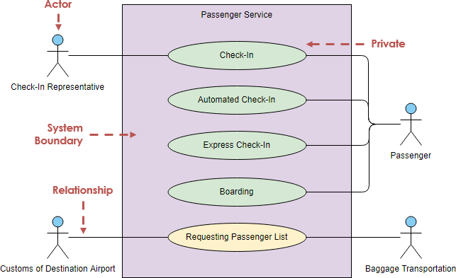
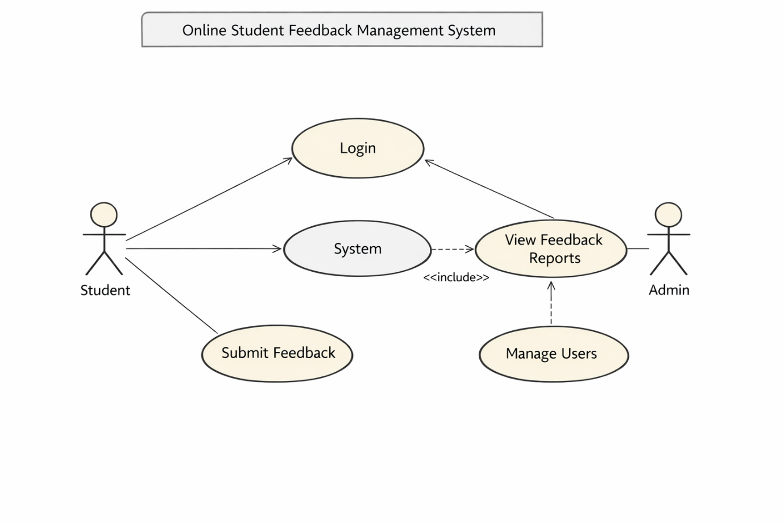
Class Diagram
https://www.visual-paradigm.com/guide/uml-unified-modeling-language/what-is-class-diagram/
A UML class diagram shows the structure of a system by displaying its classes, their attributes, methods, and the relationships between them. It helps the team understand how the system is organized and how components interact.
- Represents classes, attributes, methods, and relationships
- Helps communicate and document the software structure
- Makes it easier for developers and designers to understand the system
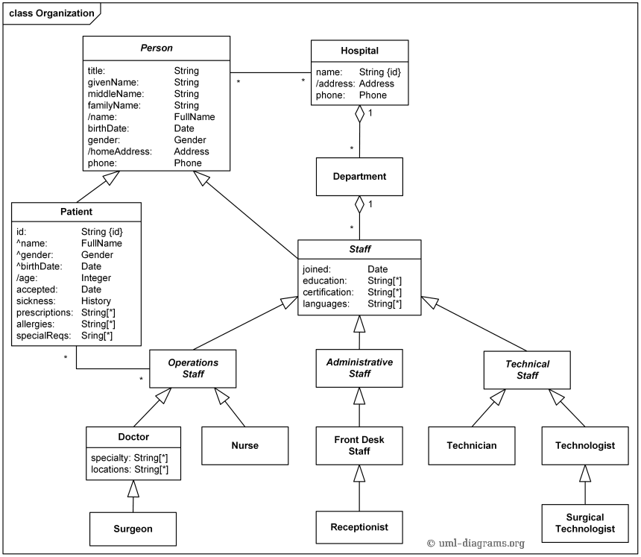

Sequence Diagram
https://www.visual-paradigm.com/guide/uml-unified-modeling-language/what-is-sequence-diagram/

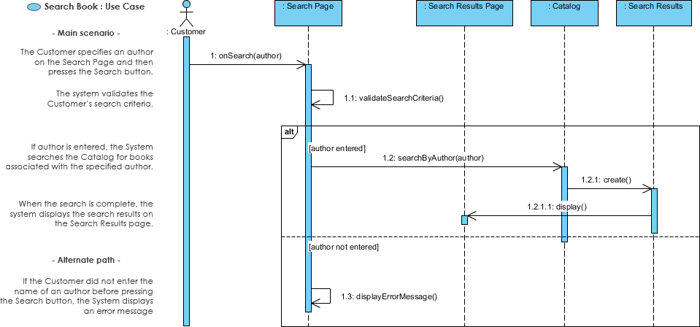
ER Diagram
https://www.simplilearn.com/tutorials/sql-tutorial/er-diagram-in-dbms
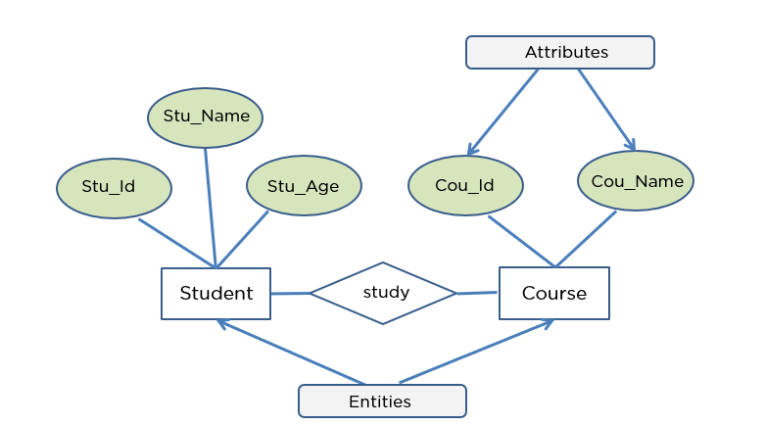
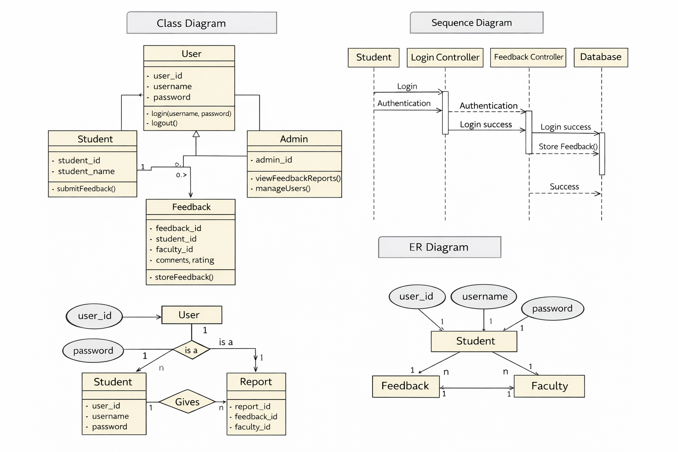

Experiment 5: Validation of Design Documentation
Aim:
To validate the design documents.
Description:
Design documents are reviewed to ensure they satisfy all requirements specified in the SRS.
Outcome:
Validated design documentation.

